There are mainly 3 steps involoved here :

- Calculate Dark Channel Prior value

- Calculate air light prior

- Calculate Transmission map

- Calculate Guided Filter Transmission map

- Restore the image

Lets first imagine our picture in the form of a grid :

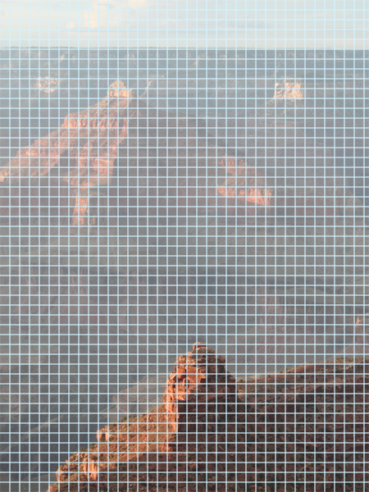

1) **Calculate Dark Channel Prior**

- Initially we take radius of 7 pixels. Now we calculate the minimum pixel value across the third axis and let's call it say "tmp".This operation calculates the minimum value for each pixel across all color channels, resulting in a grayscale image.

Red Channel Green Channel Blue Channel

Now we traverse the whole image , pixel by pixel , and for each pixel find the smallest value from the “tmp” array within the radius of 7 and then store it in the global dcp array.

The resulting image in this step looks like this :

2) **Calculate air light prior**

The atmospheric light (also known as airlight or air light) prior is aimed at restoring visibility in images degraded by atmospheric effects like haze, fog, or smoke.

When light travels through a medium such as the atmosphere, it interacts with particles and molecules present in the air. This interaction causes scattering and absorption of light, resulting in a reduction in contrast, color distortion, and loss of visibility in the captured image. The atmospheric light represents the global illumination of the scene, which includes both direct sunlight and skylight scattered by the atmosphere. It's the light that reaches the camera without being attenuated or scattered.

In this step we firstly flatten the dcp array that we calculated earlier. Flattening refers to converting a multi-dimensional array into a one-dimensional array. Now we sort this array in ascending order so as to determine the threshold for estimating atmospheric light. Now we calculate the how much is 0.1% of the total number of pixels in the image and call it say “num” . Now we initialize threshold as the num-th pixel from the back of this array. Now we select pixels from the original image where the corresponding dark channel values are greater than or equal to the threshold. This step identifies the darkest regions in the image and then we sort this new array (say “tmp”) to obtain the darkest pixels across different color channels. Now we calculate the atmospheric light by taking the mean of the **num**-th darkest pixels across all color channels by calculating the mean value along the 0th axis (columns) across all selected pixels. This gives us the average atmospheric light for each color channel.

Now we store this values in a global variable say “Alight”.

3) **Calculate Transmission map**

Transmission map is degree to which light is attenuated or scattered as it passes through the medium (such as fog, haze, or smoke) before reaching the camera or observer. Here too we will have a radius of 7 and omega initialize to 0.95 (omega controls the influence of the estimated pixel intensity on the final transmission value).

Now we traverse across each pixel and firstly calculate their region of interest by calculating “rmin” , “rmax” , “cmin” , “cmax”.

Now for each pixel within this region of interest , we divide it’s value (input image) by the “Alight” value that we calculated before .This gives us the normalized intensity value for each pixel in the region.Now we take the minimum value from this normalized intensities values and call it say “pixel”. Now we calculate the transmission value for the current pixel and store it in the global array , say “tran”.

The output looks like :

4) **Calculate Guided Filter Transmission map**

The guided filter is a type of edge-preserving filter that smooths images while preserving edges, and is used to refine or enhance the transmission map computed for dehazing.

In the context of image dehazing, the transmission map represents the degree to which light is attenuated or scattered as it passes through the medium (such as fog, haze, or smoke). The transmission map is crucial for estimating the scene's depth and for enhancing the visibility and clarity of the scene by removing the effects of haze or fog. Guided filter transmission refers to the application of a guided filter to the transmission map.

In this we use box filter . Box Filter is a low-pass filter that smooths the image by making each output pixel the average of the surrounding ones, removing details, noise and and edges from images. We store the values of this in a global array say “gtran”.

Output for this step looks like this :

The above image is the guided filter transmission map.

If we don’t apply it , our final output will like like this :

As we can see, the edges are not smooth.But if we apply it , it will look like this :

5) **Restore the image**

Now after calculating the guided filter transmission , we recover the original colourful image.

To do so we firstly declare a threshold value of 0.1 . Now we modify the “gtran” array by setting all elements of “gtran” that are less than threshold value to threshold. Doing so we effectively clip the transmission values to ensure they are not too small. Now we reshape the “gtran” array to have an additional dimension, then repeats this array along the third dimension three times. This creates a 3-channel transmission map, making it compatible with the color channels of the source image. Let’s call this “t”. Now we compute the recovered image. We subtract the atmospheric light (“Alight”) from the source image , then divides the result by the transmission map (t). After that, we add back the atmospheric light. This operation aims to correct the hazy effect in the image. Now we scale the values of the recovered image by 255. This is commonly done to ensure that the image values are within the valid range for an 8-bit unsigned integer image (0 to 255). Now we clip the values of the recovered image to ensure they are within the valid range (0 to 255). Any values greater than 255 are set to 255 and Any values less than 0 are set to 0.

This is how we get our final result which looks like this :

